Tactile Tabletop
By: Ory and Robin

Hands On Gaming

Introduction
Tactile Tabletop is a combination role playing and deck building game. It’s about building a character through choosing cards for a deck, and picking the right ones for a new encounter. It aims to provide a complex but deep system for engaging combat in a roleplaying setting. It tries to reward both mixing and matching different styles, while also those that commit to one core idea. With attack and defense die, something we call and influence die, die tokens, and more, we hope to allow for more risky but gratifying gameplay.
We created this game in response to inspirations and frustrations we’ve had with many games. We wear our influences proudly, because for every one we love, we can point out something we’d like to see be different. While we can’t name them specifically for legal reasons, we hope you notice and enjoy the bits from each of them that we have borrowed and adapted to our game.
While we are fans of learning and exploiting game systems, complexity can be paid for depth that isn’t worth having. Some examples from game experiences we’ve had: all-encompassing rule sets, feeling punished for not having a singular focus, translating lots of rules from one or more books into one or more character sheets that need to be flipped through during tense situations, and on.
Some familiar facets from our inspirations you might notice are missing, and these are in response to the above examples. You may find some scenario that is unspecified in our rules; you are encouraged to create what rules you need to make a fun game experience, of course including changing the rules we’ve decided to include in this version of the game. We believe most GM’s and players of tabletop games are used to home brewing solutions anyway, and it’s that spirit that we created this game in the first place.
Tactile Tabletop doesn’t specify a particular setting. By focusing on the mechanics of combat, our intent is to facilitate all sorts of settings: the traditional dungeon crawler, a space adventure, a post apocalyptic survival setting, any and all should work with our game system.
One more thing to note, this game is primarily focused on combat. While many tabletop games try to satisfy all possible ways to engage with the world, towards political intrigue or mystery solving, our interests are mostly around the combat systems, so our game reflects that influence. By no means should this limit you! There must be connective tissue tying the players from one combat encounter and another, and with some ingenuity these combat-focused abilities can be used out of combat for all sorts of shenanigans.
We hope this is a game you enjoy! May your adventures be exciting and timeless!

- Robin and Ory

Character Creation
Creating a character is your first step into the system of Tactile Tabletop. There are some decisions to make and trade-offs to consider: we will walk through them and provide a working example.

Building A Character

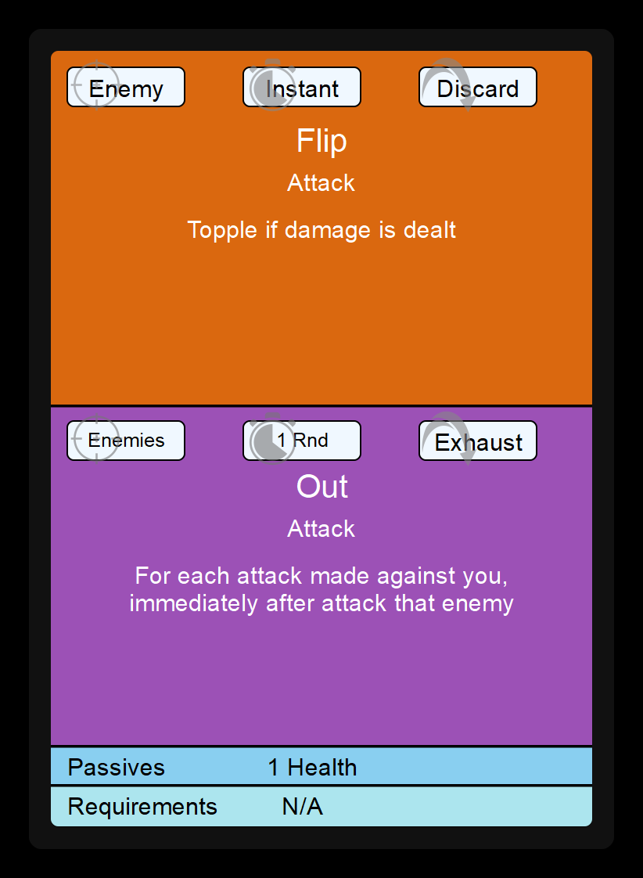
Character Cards
All characters start with 9 Character Cards. These cards together make up your Character Deck and dictate the abilities you can use in and out of combat. They also define the Stats of the character through their passive effects.

Abilities
Each Character Card comes with 2 abilities (a top and bottom). Further particulars are explained in the combat section. passives (increasing your health or stats), and restrictions (optionally present). The cards at level 1 cannot have requirements, as your character only has stats once they are finished being built.

Passives
Each card comes with Passive effects, or Passives, either increasing your character’s health or granting Skill Points that increase Stats.
Health is a resource in combat, see the later section on tokens to learn more.
Increasing Stats with Skill Points allow for acquiring higher level cards which have stat requirements (see: Restrictions), and some equipment can have stat requirements. You get to allocate the stat points to whichever stat you prefer from this list:
- Strength: your ability to physically move something
- Finesse: your ability to finely control and contort your body
- Vigor: your ability to fight off poisons, deadly blows, and other effects
- Spirituality: your connectedness to the world and people around you on a metaphysical level
- Knowledge: your ability to solve problems, intuit conclusions, and understanding and influence over natural forces
- Charisma: your ability to persuade and influence others
- Perception: your ability to see and exploiting opportunities
- Craftsmanship: your ability to turn ideas into reality

The number of total stat points you have dictates the size of your Influence die (see Table on next page).
Your Influence die is used for certain abilities, and (when prompted by the GM) to successfully interact with the world. This would be your influence die roll, + relevant stat, against some value the GM has set.
As an example, say you want to convince a shopkeeper to let you into an underground market. In order to do this you will need to convince them to tell you. You would roll your influence die and add your Charisma modifier to the roll. If this beats the value the GM has set, you succeed and the shopkeeper decides to let you in on their secret.

Restrictions
As you level up, you add more cards to your Character Deck. Some cards are more powerful, but have minimum stat requirements, called Restrictions, and you cannot add a character card to your deck if you don’t meet the requirements.
You may intend to eventually add one or more cards that have specific requirements, and assign your stats accordingly. Alternatively, you may have a particular kind of character in mind, and set aside stats that fit the idea of that character. In this case, as you level, you’ll discover what kinds of cards end up fitting the character you’ve built.
There’s no wrong way to build a character, and no one card should or shouldn’t feel necessary to include for any one character deck. People are multi-faceted and surprising, and your characters can be too!

Influence Die Chart
Skill Points Amount | 0 | 5 | 7 | 9 | 12 | 16 | 19 | 23 | 27 | 31 | 36
Influence Die Size | 1d4 | 1d6 | 1d8 | 1d10 | 1d12 | 3d4 | 3d6 | 3d8 | 3d10 | 3d12 | 3d20

Sample Character : Zin Fantallay

Character Card | Passives
Gain Confidence / Risky Maneuver | 1 Health Token
Reposition / Coward’s Ultimatum | 1 Health Token
Land of Barbs / Fibrous Hold | 1 Skill Point
Mockery / Encourage | 1 Skill Point
Demand Resilience / Demand Weakness | 1 Skill Point
Pinned / Murder Markings | 1 Skill Point
Setup / Takedown | 1 Skill Point
Pocket Sand / Slippery Escape | 1 Skill Point
Dodge / Expect | 1 Health Token
Totals: | +6 Health Tokens | +3 Skill Points
Skills Allocated: Charisma 2, Finesse 2, Strength 1, Knowledge 1
Influence Die: 1d6

Character Tokens
Health Tokens
All characters start with 3 Health Tokens. These have a front and back side: as you take damage, these tokens flip from the healthy state to damaged state, and as you are healed they flip back from damaged state to healthy state. You also get 1 additional health token at each level.

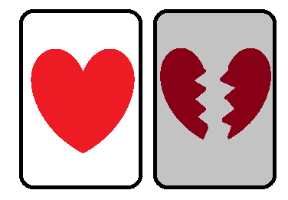
Contact Tokens
All characters start with 2 additional tokens, and get 2 additional at each level, which can be more health tokens or Contact Tokens.

Contact Token Types
Contact Tokens come in three types: Attack, Defense, and Influence. These map on to the 3 categories of Contact Dice types used in the game.

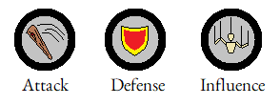
Contact Token Uses
One function of Contact Tokens is to place them on a target to increase die rolls against them, as follows.
- For every Defense Contact token you have applied, increase by one all defense values you calculate against that target
- For every attack contact token you have applied, increase by one all attack values you calculate against that target
- For every influence contact token you have applied, increase by one all influence values you calculate against that target
The other function of Contact Tokens is to consume them to use or empower certain powerful character card abilities. A card will dictate if it requires consuming a token to use, or if it takes additional effects if a token is consumed, and will describe which tokens to be used in this way.
Once tokens are applied to a target to increase die rolls, they cannot be consumed for character card abilities.
All Contact Tokens that get consumed or are applied to a target that dies are flipped over to indicate that they are expended, and cannot be used again. All Contact Tokens are returned to you upon a Long Rest, in the same way that exhausted cards are returned to you.

Mark Tokens
The last type of token is a Mark Token. Certain character abilities apply or consume Mark Tokens according to the rules written on the card. These tokens are ephemeral, only lasting in the context of the combat encounter. Though they are harder to apply, they also enable even more powerful card abilities than what, say, an Attack Contact Token could do alone.

Sample Character Continued : Zin Fantallay
Contact Tokens: 1 Attack ; 1 Influence
Total Health: (3) + 3 = 6 HP

Weapons
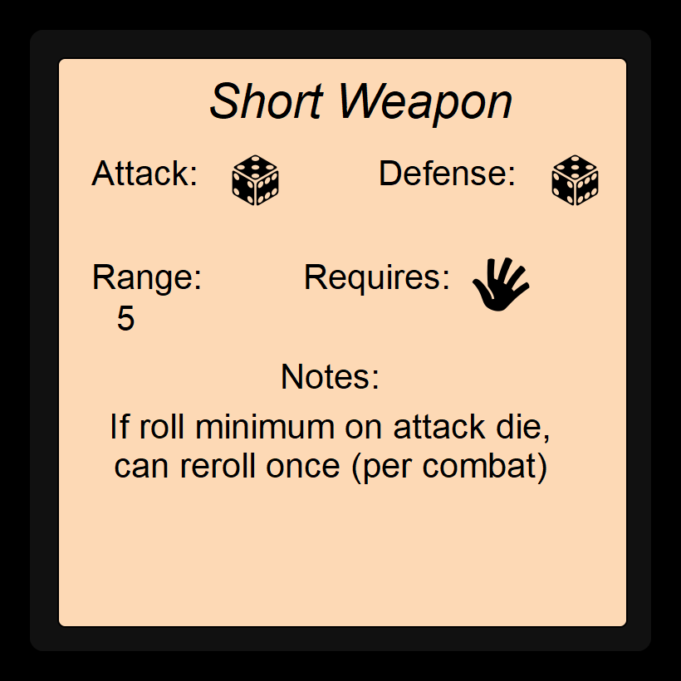
Beyond the character’s abilities and their tokens to withstand attacks/empower their abilities, the character has weapon(s).
Weapons define:
- The dice to roll for Attack and Defense rolls
- The distances that attacks can reach with the Range value
- Requirements that must be met in order for them to be used, usually having 1-hand or 2-hands occupied by using them.
  - more powerful weapons may be offered that carry stat requirements as well, and some rare weapons might not have any handed-ness requirements
- Finally, special rules unique to that weapon that enable a style of use in combat

Specific weapon descriptions are left unspecified intentionally. If you want your character to use a tree branch, or a piece of rebar, or a neon staff, or psychic/magical effects, all could be described by the Short Weapon. A long bow, or a rifle, or a railgun, or a magical beam, could all be described by the Long Shot Weapon. We encourage creativity in defining your characters weapons to best suit them to your character.
Unless the game requires a particular flow/way of interaction, it’s pretty vital for characters to have at least one of these weapons, so we have placed it in the Building a Character section.

Weapons

Weapon Name | Attack Die 1 | Attack Die 2 | Defense Die | Range | Requirement1 | Requirement2 | Extra Notes
Long Shot Weapon | D4 | NA | D4 | 60 | 1-hand | 1-hand | If attacking beyond 30 feet, increase attack by 1d6
Great Castor | D6 | NA | D4 | 40 | 1-hand | 1-hand | Damage from attack tokens is 2 instead of 1
Reach Weapon | D6 | D4 | D6 | 10 | 1-hand | 1-hand | Can be thrown at ranges beyond 10 ft:  Range = 25  Damage += 1d6
Great Weapon | D6 | D4 | D6 | 5 | 1-hand | 1-hand | If you slay an enemy, add 1d6 to your next attack
Short Shot Weapon | D4 | NA | D4 | 25 | 1-hand | NA | If you use two hands on this weapon, add 1d6 to damage and 10 feet to range
Hand Castor | D4 | NA | D4 | 20 | 1-hand | NA | On dealing damage, you may return a used attack token
Short Weapon | D6 | NA | D6 | 5 | 1-hand | NA | If your attack die rolls a 1, reroll that die (once per combat)
Blocking Weapon | D4 | NA | D8 | 5 | 1-hand | NA | If you successfully defend an attack, deal 1 damage to enemy
Hand Weapon | D4 | D4 | D4 | Close | 1-hand | NA | Add 1 damage for consecutive attacks on same opponent
Unnarmed | D2 | NA | D2 | Close | 1-hand | NA

Armor Set
Armor Sets grant limited use abilities. They are best selected when they cover a weakness in your character’s setup.
For example, a character can have abilities that involve lots of card discarding and recovering, so the Preparation Set is good for them. For another example, a character could have a low amount of health, so the Deflector set or the Clutch set can be useful.

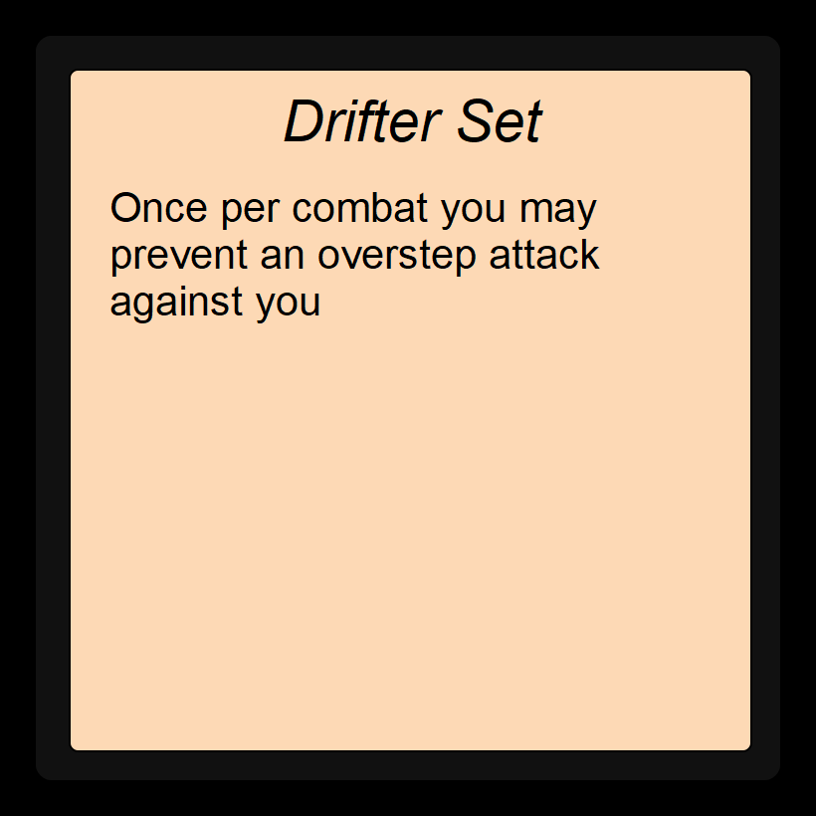While armor sets aren’t as crucial as weapons, it’s recommended that the characters start with one, so they exist in the Building a Character section.
Armor Sets

Armor Name | Set Ability
Drifter Set | Once per combat: prevent attack against you
Deflector Set | Once per combat: reroll defense dice
Preparation Set | Once per day: increase your hand size for combat by 1
Marauder Set | Once per day: Play additional action in a turn after taking damage
Mending Set | Once per day: heal yourself by an amount equal to your level
Clutch Set | Once per day: if an attack would Down you, set health to 1 instead

Enhancing A Character

Beyond creating a character, we have other built in mechanisms for enhancing the character, granting them additional health, stats, or abilities that are separate from the character themselves.

Equipment
Other than armor, specific slots on your character are for wearing Equipment. These provide bonus abilities, capabilities, or modifiers to certain kinds of rolls.
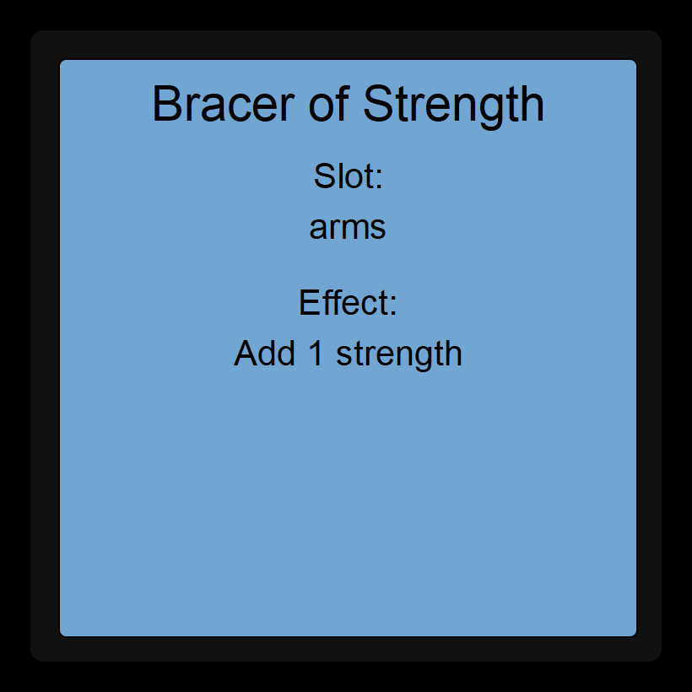
Regardless of body type or number of limbs, only one item of each slot can be used at one time. For example, if you have 2 helmets, even if you have 2 heads, you have to pick one to have an effect at the start of combat.
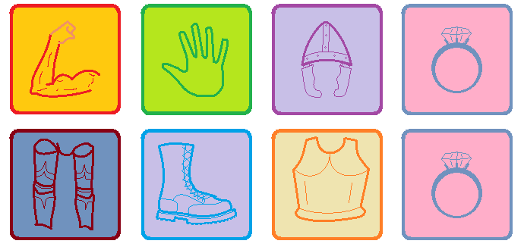

Equipment
Equipment Name | Slot | Effect
Thinking Hat | Head | While worn, grants +1 Knowledge
Enchanted Breastplate | Body | Add 1 to all defense values
Ring of Aulm | Accessory | While worn, grants +1 spirituality
Hydraulic Grip Gauntlet | Hands | Cannot be disarmed
Angel’s Blessing | Arms | Can float 5 feet off the ground, reduce fall speed
Nice Pants | Legs | While worn, grants +1 charisma
Spring Shoes | Feet | When Jumping, gain an extra 10 feet of movement

Consumables
Consumables can be used in place of character card abilities in combat when taking a non-card action (see combat section), and generally are removed from your deck upon use. You decide whether the consumable acts in the place of a top or bottom ability when acting in a turn.
These are items like a potion that can be quaffed, a magical staff with limited charges, some mechanical equipment with limited battery, a bag of souls, and so on. The specifics are up to your GM and the setting. Below are just some examples:

Consumables
Name | Description
Small Healing Potion | Twice, heal 1d4 Health Points
Hand Mirror | Polished Silver with a handle, covered in etchings
Emerald | A green gem
Wind Instrument | Either a flute, bagpipe, or whatever else
Pint of honey | Honey from bees in a glass jar
Lighter | A pressurized container of flammable oil, with a sparkwheel and button on top to create a small flame
Glass Bottle | Bottle made of glass, can hold a pint of liquid or whatever else can fit
Bag of metal balls | Can be dropped on an adjacent space to make it a tripping hazard, Finesse of 2 or become Toppled
Metal Chain, 5 ft. | A chain of iron, 5 feet long
Wooden Pole, 10 ft. | A thick wooden dowel, 10 feet long (comes in 2 5ft sections)
Set of dice | Can be used to roll random numbers
Bag (Linen) | A bag made of fabric, volume of 20 gallons
Magnifying glass | Polished concave lens with a handle, shows fine details
Grappling Hook | A grappling hook on the end of 30 feet of rope. Finesse difficulty to attach to a point is +1 For every 5 feet of distance
Net (Rope) | A net made of rope. If dropped on a foe, their movement cannot exceed 5 ft until they free themselves. Must attack the net (HP 3) or succeed a strength check (3) to escape the net
Rope | 50 feet of rope made of animal fibers
Staff of Magical Missles | 3 times a day, you can use this staff to cast a spell launching a 3d6 blast towards a target within 30 feet
Wand of Suggestion | Once a day, you can use this wand to increase your next calculated influence value by 1
Reusable wallpaper | Up to 5 times, place a decorative paper wallpaper (10x100 ft)

You’ll probably notice that we don’t specify prices. Partly, this is because the currency you use will depend on the setting of your campaign (dollars, gold pieces, company scrip, seashells, etc.), and partly this is because anything we put would be arbitrary anyway. No one is going to simulate a full economy of supply and demand and inflation and so on. Items cost as much as is reasonable for them to cost, if they have a cost at all. Work with your GM on managing what can be bought and for how much.

Influence Cards
Finally, there are influence cards. These can be positive or negative, but are added to your character card deck (meaning they can be drawn for combat, see later section on Starting Combat for more details).
Feature cards are very contextual, so we provide blank cards for the GM to fill out. To give you ideas, below are some examples.
Influence Cards
Name | Description
Blessing of Yindar | Duration: 5 Rnds ; Action: As long as sunlight is touching you, gain +1 to all rolls
Bog Witch Curse | Duration: 1 day ; Action: flip a coin after each attack. If heads, take a -3 penalty
Broken Leg | Action: gain 10 ft movement, take 1 point damage. Passive: -1 strength
Faulty Computer | Duration: Instant ; Action: Move vehicle 20 feet in a random direction
Augment lvl 1: Legs | Action: powered kick, 2d8 damage, 5ft range ; Passive: +1 strength
Fresh Coffee | Duration: 1 hour ; Passive: +2 Knowledge checks, +5ft movement when taking an action that gives movement

Sample Character Continued : Zin Fantallay
Armor: Drifter Set
Weapons: Short Weapon (Curved Sword), Short Weapon (Gladius)
Equipment: Thinking Cap (New Knowledge total: 2)
Consumables: Bag of Metal Balls, Hand Mirror, Small Healing Potion

Feature Cards
To be clarified later. Ideas: play around with the rules/fundamentally change gameplay somehow, get one at 3, 7, 11?

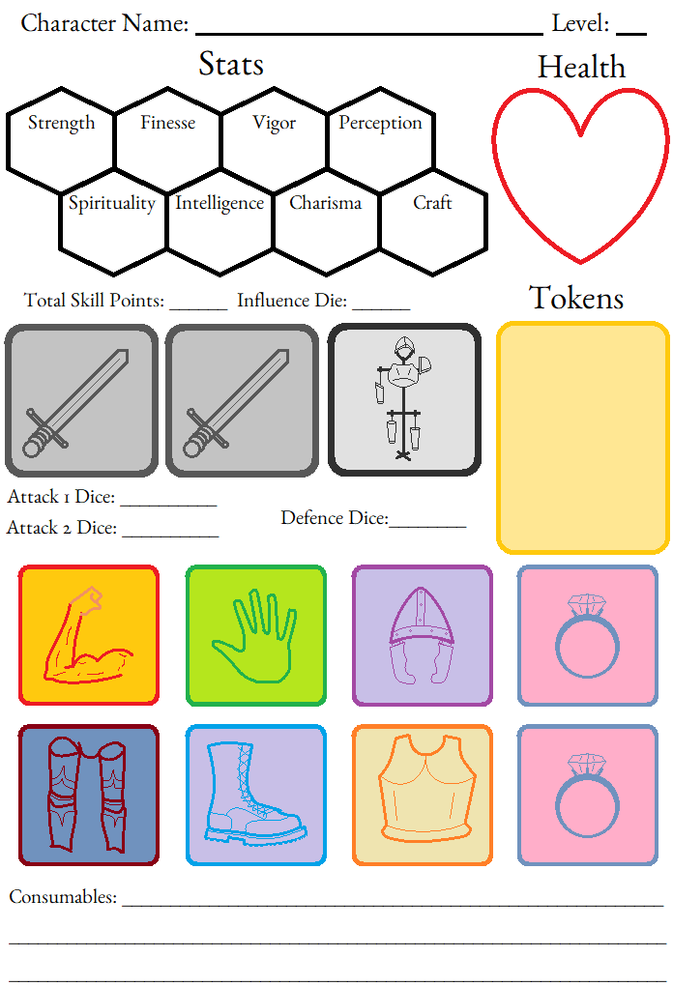
Blank Character Sheet

Sample Character Finished : Zin Fantallay

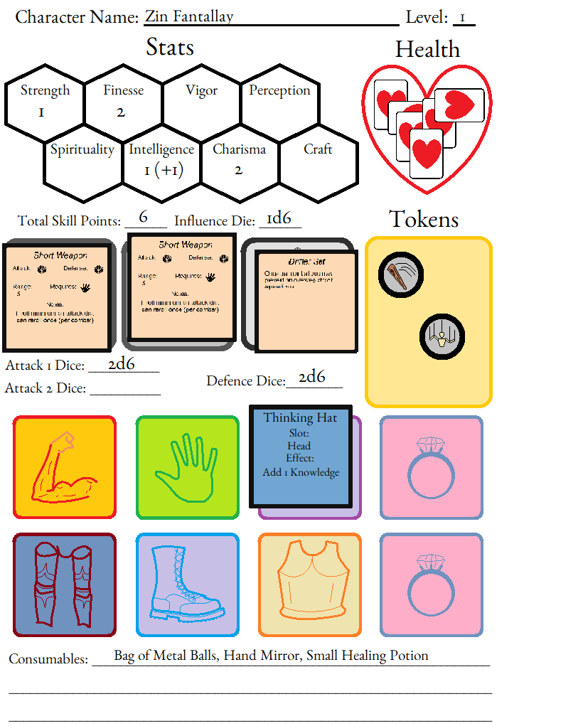

Combat

Combat is when opposing forces (the characters and some other non-player entity(ies)) come to a clash. Differing goals come into conflict, and resources (namely health) are tested against attacks (namely abilities/actions)
All attacks are responded to by the defender with defense rolls, and targeted influence rolls are opposed with opposing influence rolls.

Starting Combat
At the start of combat, shuffle your deck and draw 7 cards to bring into play.
Then combat order is defined, starting with whichever group initiated the combat. Turns alternate between the players and enemies. When one person of the party enters combat, the whole party enters combat.

Turn Order
When it’s the opponent’s turn, they all act in no particular order, but all of them act before their turn finishes.
When it’s the player’s turn, they act in whatever order they collectively choose, and all have a chance to act before their turn finishes.
Turn order for combat is established by whoever initiates. This carries with it some implications:
Much like real life, tense conversations can escalate into violence. If you think a fight is about to happen, it’s probably in your interest to be the one to start it. However, violence usually comes with consequences (who is at fault/to be reprimanded, but also who lives to reach the next day). Tread carefully!
In addition, surprise rounds are particularly effective against enemies, and can be quite debilitating against the players, especially if they have particular setups that can be interrupted. Tread carefully!

Taking a Turn
Each character’s turn consists of taking two actions. These can either be card abilities, or non-card actions.
Non-card actions are more generic types of actions, but typically non-consequential/non-aggressive activities. They could be pulling a lever or pushing over a table, but often are used to regain cards from discard. All non-card actions grant 15 feet of movement.
Card abilities describe their effect. Some grant movement, establish an attack (assuming there’s a target to attack in range), apply an effect to an area, summon an ally, apply a buff, or apply a debuff. The particular flavor of how they are played out are left to the player to describe. For example, the same basic attack from the fighter is a sword swing, but to the mage is a blast of magic, and so on.
You decide both actions you’re going to take before you take either and play out your turn.

Movement
By deciding both actions before you play out your turn, you add together the movement granted by the card abilities and non-card actions. This total of movement can be used in 5 ft increments and be used before, between, and after your actions & abilities.
As an example, for your turn you decide to play an action card’s top ability, and for your second action you decide to take a non-card action to read from a book in your items. The card’s ability that you played states that you may add up to 20 feet to your movement, and also targets an enemy for an attack. The book you read (which activates some buff to allies around you) is played as a non-card action: by being a non-card action, you gain up to 15 feet added to your movement from that alone. Altogether, this means you have 35 feet of movement to use this turn.
Say an enemy is 10 feet away. You could use up 10 feet of movement (leaving 25 feet of movement left) to get in range, and then attack with your top card ability. You decide to move another 10 feet (leaving 15 feet of movement left), and then read your book. With the last 15 feet of movement, you choose to move 15 more feet away from the battlefield, using up the rest of your 35 feet of movement for that turn.
Card abilities that grant movement, but can’t meet target/range requirements (target is still too far away after moving) will still resolve (ie: go to discard/exhaust), but any movement they provide is granted regardless.

Taking Actions: Details

Non-card Actions
Any use of a non-card action grants the character up to 15 ft of movement. In addition to this, one of the following at your discretion also happens:
Game Mechanics Ability
- Returning target card from the discard pile to your hand
- Use of a consumable
Interact with World Ability
- Arming/disarming of a weapon
- Locking a door
- Pushing a boulder
- Striking a pose
- etc...

Many card abilities go into the discard pile, so typical play involves using a non-card action to return your cards to your hand for the following round.
In addition, many cards don’t grant movement as a part of how they execute. Using a non-card ability to position yourself before taking a card ability is common.

Card abilities
Each card has a top and bottom ability: usually you’ll play the top ability from one card and bottom ability of another card for your entire turn, though combining a card-ability and a non-card ability is a valid play. The text on the card will describe how the ability is executed.
Each card ability has a target, a duration, may involve one or more die rolls, and eventually end in some state: discarded, exhausted, or returned to hand.
For sake of conciseness, cards might describe values in terms of variables (X, Y). How those variables factor into the ability are determined by the card’s rules.
You cannot play 2 top or 2 bottom card abilities simultaneously. You must meet card text requirements (ie: be in range, have cards to discard, etc.) for them to take the state effect.

How Targeting Works
In order to target an enemy, they must be in range for the type of action. A target of a weapon attack must be in range of the weapon via the weapons stats, and a target of an influence action must be inside your influence range (default 50 feet, requires line of sight).
If the target is an enemy and the ability is an attack, the opponent rolls their defense die to reduce the amount of incoming damage.
If the target is an enemy and the ability involves an influence die, the opponent rolls their influence die to prevent the success of the ability.
Some abilities have a target but don’t involve a die roll at all: the rules of the ability will dictate what effect it will have.

How Duration Works
If the duration is something longer than Instant, then it lasts in Active. The ability can expire in one of three ways: either the duration expires, another Active effect is put into play, or the trigger for the ability happens within the timeframe of the duration.
For example, a card ability might have a duration of one round, and state that the next attack against you is reduced by your level in value (ie: at level 2, enemy’s attack is reduced by 2). Because the ability is triggered by the next attack, the first attack against you is reduced, while the second attack is not reduced. Also, if you are not attacked by the end of that round, the effect ends having not been used. Finally, playing a second Active card replaces the original effect. Regardless of how the effect ends, the card is moved to the specified location afterwards, hand, discard, or exhaust (see next section: How Abilities Finish).
1 round is relative to the character, and is from the start of their current turn to the start of their next turn.
We recommend tracking an active cards duration with a die placed on the active card until it expires or is replaced.
[tracking summons health]

How Abilities Finish

Icons on the card indicate where the card goes after being used: returning back to your hand, to the discard pile, or to the exhaust pile.

Discard
Discarded cards go into a separate pile during combat, the discard pile. Discarded cards cannot be used again until returned from the Discard pile. This can be done with certain card abilities, or with a non-card ability.

At the end of combat, or when using card abilities outside of combat, generally discarded cards return to be used immediately. There isn’t a turn order outside of combat, so (within reason) it’s assumed you can spend a little time resting between using an ability and using it again (returning it from discard pile via a non-card ability).

Exhaust
Exhausted cards go into a separate pile during combat, the exhausted pile. Exhausted cards cannot be used again until the character performs a Long Rest. Abilities that are exhausted are generally more powerful abilities.
Outside of combat, these exhausting abilities are still exhausted.

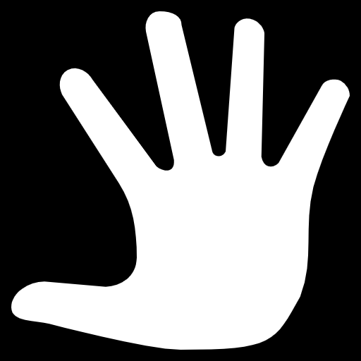

To Hand
To Hand cards return to your hand immediately after use. These cards often have smaller and immediate effects.

Giving and Receiving Damage
When attacking (or being attacked), those impacted must make opposing attack and defense rolls. These add to an Attack Value or Defense Value, respectively.
If the defense value is higher, then no damage is dealt. If the attack value is higher, then the difference in values is how much damage gets dealt to the defender.
For example, if my defense roll is 1d4 + 1d6, and I roll a 2 and a 4 respectively, then my defense value (with no other considerations) is 6. If the opponent’s attack roll is 4d4 and they roll a 1, 3, 2, and 2, then their attack value is 8 (without any other considerations). The difference, 8 - 6, is 2, so I take 2 points of damage, flipping over 2 health tokens to the damaged state.

Attack and defense values can be modified by abilities (buffs from allies or debuffs from opponents), equipment (armor or magical items that increase/decrease effects), and Contact Tokens. Ultimately however, both attack and defense values evaluate to a singular value before they are compared with each other

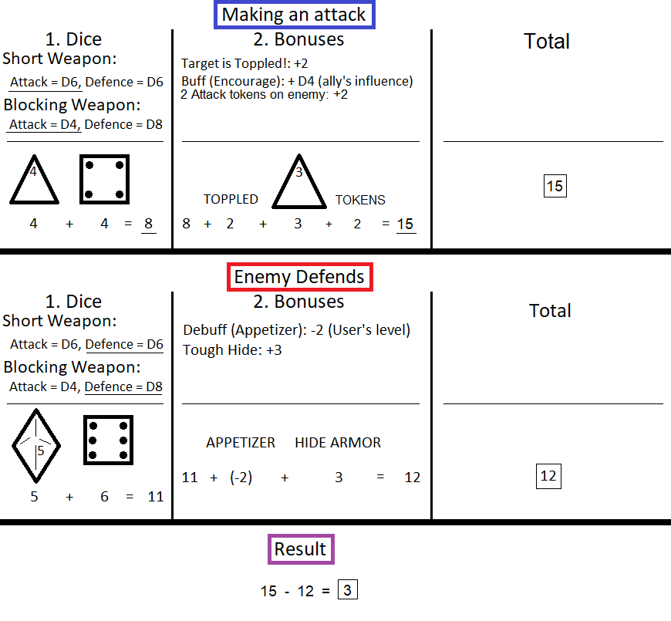

Range, Targeting, and Facing
Targeting is a combination of meeting range requirements, and targeting requirements.

Range
Ranges vary from Close, and then every 5ft increment (close, 5, 10, 15, etc.). It takes 5 ft of movement to move from 5 ft to Close. Close range means you occupy the same square as the opponent.
Weapons dictate their range of effectiveness. This range applies to any attack action from a card ability.
Abilities that use the Influence die must be within the Influence Range. The Influence Range is 50 ft at base.

Targeting
Provided a target is in range, a target falls into one of these categories:
- Enemy: enemy combatant, be it a creature, an illusion, or anything else considered hostile
- Enemies: multiple enemy combatant
- Ally: other players you’re playing with, or NPC that is helpful
- Self: your self.
- Area: a space, occupied or otherwise, of some specified dimension. Card ability should dictate the radius, or length/width of an area that is affected.
- Plant: whether an ally, enemy, or neutral party, sapient or otherwise, this target must be a plant. Up to GM discretion
- Animal: Same as Plant target, but for Animals.

Overstep Attack
An Overstep Attack is a ‘free’ attack by an enemy, when moving into our out of close range. These attacks are the combatant’s most simple attack: Unless supported by an ongoing buff/debuff, these attacks are not otherwise modified by effects (cannot apply special effects to this attack)
Overstep Attack do not happen if the enemy has not perceived the player.

Movement
Through use of non-card actions, or card abilities that grant movement, you can move in 5 ft. increments around the battlefield. Any ability that has the phrasing “you gain XX movement” applies to the total movement you can make this turn.
Movement can be applied before, between, or after your actions. For example, if your movement is 15 ft., you can move forward 5 ft., attack, and then move away with your remaining 10 ft.

Example
Below is an example of how a combat might start and then play out in a couple of rounds:

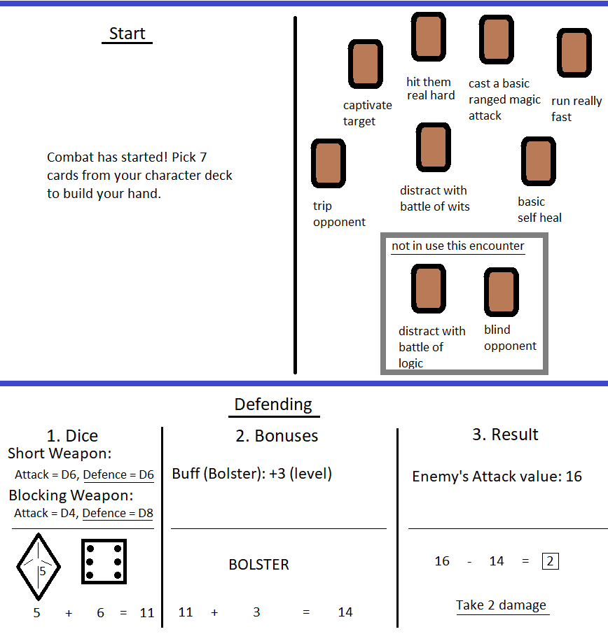
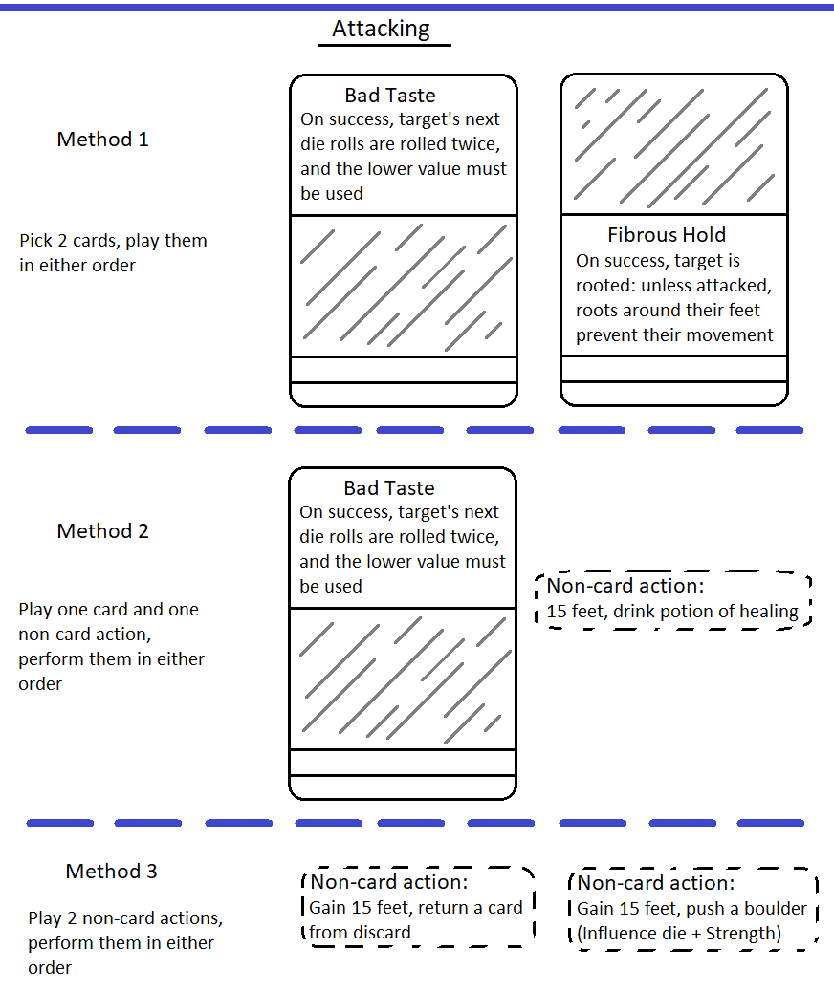

Non-combat
Generally, non-combat interactions play by the same rules as combat, but on a longer scale. Cards that are exhausted still get exhausted, but cards that are discarded and can return to your hand within reason (at the GM’s discretion).

Additional Rules

Reactions
A Reaction is a way a character can prepare an attack or other action to something you suspect/fear will happen.
Select an action (a card ability, or a specific non-card ability), and designate a trigger. The trigger must be accepted by the GM as reasonable (see Triggers below). At this point, the Reaction is in the Ready state. If the trigger is met while the reaction is Ready, then you play out that card ability as described on the card. Otherwise, if the conditions for the trigger render it invalid or you dismiss the reaction, you exit the Ready state without playing through the action/ability. This ability is not discarded/exhausted it it wasn’t triggered.

Triggers
A trigger should be something specific, usually something that applies to a specific area, seeing something specific, or something entering a specified area.
There is no limit on how specific a trigger can be, but it cannot be too broad. It is up to the GM’s discretion as to whether a specified trigger is too broad or not. Some examples:
- I state that I want to drop a bucket I’m holding as soon as the duke standing in front of me turns around. I can hold this in the Ready state until it happens, I dismiss it, or I’m my trigger is rendered invalid (the duke unexpectedly teleports away, or they fall over dead), see Exiting Ready State.
- I’m currently in a dark cave, and I can’t see well. I specify that I want to attack the next enemy I see with a card ability, whenever that happens. The GM suggests that I can’t be so discerning, and offers that I can prepare a reaction to attack the next living thing I see. Hopefully this is an enemy, and not an ally!
- You can specify a trigger of X number of enemies being present in an area that the ability can affect:. This enables effective use of area of effect abilities.

Exiting Ready State
Except for when a trigger’s condition is met, which exits you from the ready state, a trigger’s conditions can be failed to be met either by a change of time (expiration), or of situation (trigger no longer applies).
In combat, expiration happens if the trigger’s conditions aren’t met by the start of your next turn. You can declare that you will spend the next turn waiting again, though consider that you are sacrificing your turn in order to get the desired effect of the ability with the trigger.
In or out of combat, a trigger can no longer apply for numerous reasons, up to the GM’s discretion. Some illustrative examples:
- If the trigger was on something entering a doorway, and you’ve been teleported to another plane of existence, you’ve been forced out of the ready state.
- If you want to attack the next thing that walks through a doorway with your ranged weapon, and then you walk out of sight of that doorway, then you’ve moved yourself out of the Ready state.
If forced out of the ready state without the reaction being triggered, the abilities/items/etc. return to your hand as applicable. There is no cost, except for the time wasted waiting for something that didn’t end up happening.
Worth specifying, exiting the ready state involuntarily does not mean that the action can’t happen, just that it doesn’t happen in response to the trigger. Expanding on the triggers from the previous section:
- I state that I want to drop a bucket I’m holding as soon as the duke standing in front of me turns around. The duke falls over dead, exiting the ready state. Given that I am allowed time to act, I drop the bucket anyway.
- I’m currently in a dark cave, and I can’t see well. I have specified that I am prepared to attack the next living thing I see. I recognize as my rival’s voice coming from right in front of me. I cannot see them still, but I decide to attack where I think they are in front of me.
- You can specify a trigger of X number of enemies being present in an area that the ability can affect. Throughout the enemy’s turn, 1 less than X are now in that area. Because a turn has expired my reaction is no longer in the ready state. Wanting to not waste another turn waiting, I enact that ability on the area (or a slightly different area, doesn’t matter) on (say) those X-1 enemies.

Buff/Debuff rules
Multiple allies can buff the same character, but they each can only apply one buff to that ally. Said another way, you can receive buffs from multiple allies, but each ally can only give you one buff each. If already buffed by one ally, and that ally applies another buff, it replaces the previous buff.
Debuffs act the same as buffs.

Being Downed
When all of your health tokens are flipped to the damaged state, you are Downed. This means:
- your character is unconscious (can take no actions)
- You choose a number of cards (current level in amount) and move them to the Graveyard pile. These can be from any location (in hand, discard, exhaust, character deck).

Graveyard
Cards in the Graveyard cannot be used in or out of combat, but they still apply their passive effects (increasing stats or health).
Each subsequent death results in more cards put into the graveyard, but the graveyard can only increase until you only have your hand size left in cards. You always have your hand size in cards available to use.
In order to regain cards lost to the graveyard you must level up. This returns all cards in the graveyard to your Character Deck.

Recovery
Recovery from being downed, and being able to take actions again, requires:
- Being healed for half of your health tokens (rounded down), or
- If the encounter ends and you are still downed, you recover with up to your level in hitpoints.

Death
If you continue to take damage while Downed up to your max health, then your character is permanently slain. You can track this by rotating each damage token for each point of damage you take past 0 health.The purpose of this ruling is not to encourage character death through normal interactions, but rather to enable character death due to extreme factors, such as jumping in lava with no special equipment.

Leveling
Tactile Tabletop doesn’t have a native leveling system such as experience points or milestones. It is left up to the GM to decide when it is appropriate to apply a level up, depending on whatever rubric they decide.
Each time you level up, you add:
- 2 character cards that you meet the requirements for
- 1 health token
- 2 tokens of your choice (health or contact)
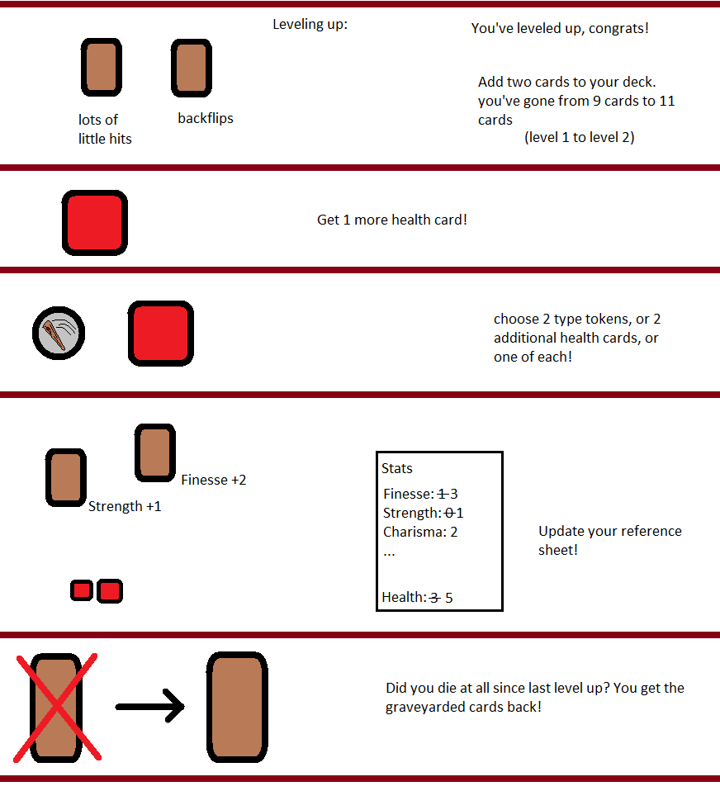
In addition, any cards in the graveyard are returned to you.

Currency
Tactile Tabletop doesn’t have a native currency system such as gold coins or dollar bills. It is left up to the GM to decide if currency is relevant for their game, and how to offer or use it.

Average Player Level | Cheap Priced Item Examples | Moderate Priced Item Examples | Expensive Priced Item Examples
1-3 | Food | Lodging | A decent Weapon
4-6 | Excessive Adventure Supplies | Travel | A base of operations
7-9 | Buying the pub a round | A powerful artifact/weapon | One-of-a-kind items
10+ | A hefty bribe | A trading ship | A small army

Curses
Curses are a specific ailments that fit into (or on top of in-use) equipment slots. The GM can assign these curses to players in a number of forms: If the character equips a cursed magical item, if the character breaks a leg, if a status effect of an area has a more permanent effect, and so on.
Like other equipment cards, the card will describe the debuff that it applies, but will also list how it can be lifted.

Rules Around Durations
Only one summoned creature or effect on an area can exist at one time. Using another ability to summon something before the first summoned thing naturally expires banishes that first summon.

Any ability that has an effect lasting longer than an Instant amount of time can be dismissed by the caster on their turn.

Die Chart
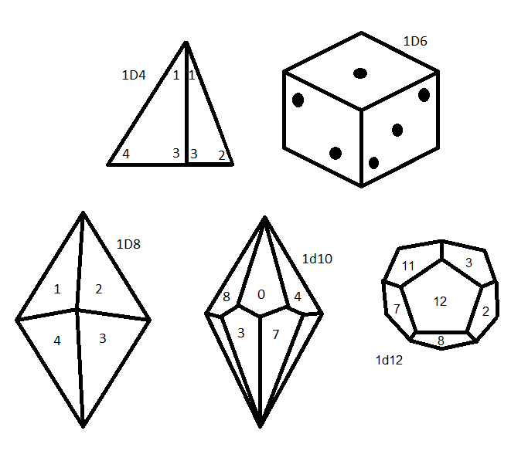

Physical Changes
Some card abilities, potions, blessings, or other effects might have temporary or permanent effects on tha character. The mechanics of these changes should be specified in the situation that they are applied, but implied in this effect is how it might impact how you can interact with the world. An attack that grants you arms of fire might cause a tapestry to catch fire; a hardened skin of stone might terrify a populace unfamiliar with such a feature; and on. We can’t provide rules for each and every contingent effect or change in ones body, but keep it in mind for fruitful roleplaying.

Interactions (outside of combat)
TBD

Notes for GMs specifically

Creating NPC’s
This section lists some guidelines and a few examples of how a GM might create NPC’s, but it is by no means intended to be definitive or exhaustive. Those taking on the GM role are encouraged to create interesting NPCs that fit whatever setting is being played that will produce the most fun experience for your players.

Principles
- NPCs should have lower defense die, but higher health points total. The lower defense die means people attempts to do damage are not suddenly dwindled, and the higher health total allows for more rounds of engagement and back and forth tactics
- The abilities NPCs have don’t need to directly emulate the character cards, and arguably shouldn’t. Good NPC abilities are specific and simple, while fitting narratively with the given NPC
- Contact tokens are particularly potent, so you can give some of them to powerful NPCs to give them an upper hand.
- NPC abilities, when used, don’t generally go into piles like discard, exhaust, etc. unless specified otherwise. The same actions can be used round after round. They will have a set of actions with a defined ruleset for their use. These actions are tied to themselves, and not to a card.
- NPC abilities can be specified as top or bottom to control what combinations can be deployed, but some NPCs have actions that are not specified as top or bottom. These can be treated as a top or bottom at the will of the GM.
  - In addition, typically an NPC can only use one action per turn (cannot use the same action multiple times), unless it’s not specified as either top or bottom

Examples
Goblin
HP: 10
Defense: 1D4
Top action: Stab. attack 2D4, range Close
Top action: Bow. attack 1D4, range 15 ft
Bottom action: Scurry. Gain 20 ft. movement
Bottom action: stink bomb. Range 15ft., attack 1d6, if attack beats defense then target has -2 to all attack values for 1 rnd

Holy Knight
HP: 60
Defense: 1D6
Action: Slash. Attack 1D10, range 5 ft
Action: Holy Ray. Attack 1D8, range 20 ft.
Action: Consecration. Attack 2D6, area around self 15 ft., 1 use per battle
Action: Angelic Flight. Movement 25 ft.

Table Dragon
HP: 100
Defense: 1D6
Action: Claw. 2D4, range 10 ft., can be used once without using up a top/bottom action
Top Action: Fire Breath. 2D6, Range 100 ft., Can be used once every 1d6 rounds
Top Action: Flight. Movement 50 ft, can be through the air

Alien Mech Ball
HP: 40
Defense: 1D4
Top Action: Rollout. Movement 30 ft, all opponents in path defend against 1D6 + 1D4 damage. Those who take damage are toppled and don’t block ball’s path, those who don’t take damage prevent ball from moving through their space. Toppled enemies can be approached in close range.
Bottom Action: Sticky Bits. 3D4, range Close

Creating your own cards
Homebrewing is something we’ve experienced with all tabletop games at one point or another. It’s essentially why Tactile Tabletop exists in the first place. In the spirit of this, we encourage the player’s and GMs creativity in creating their own character cards.

We recommend these principles when designing your own cards:
- Don’t make card abilities that are too useful. A card that you always want to use every round for most any combat makes for less varied gameplay for you and your fellow players
- Consider what you have available to you to balance the card:
  - if it’s an attack, where is its bonus derived and does it scale?
  - Is the target a specific type of enemy, any enemy, or multiple enemies/things in an area?
  - What are the passives, if any, for this card?
  - When the card is played, does it return to the hand, go to the discard pile (to be used again on the turn after next usually), or go to the exhaust pile (once per day)?
  - Generally cards that exhaust themselves are more powerful than those that are discarded, and discarded cards are more powerful than those that return to your hand
  - Level one cards (those that have no stat requirements to be taken) should only give one health point or one skill point
- Cards that apply Mark should, generally, either be of high cost or be at risk of not being applied
  - In reflection of that, abilities that act upon marked targets should be more powerful
- Cards that discard/exhaust other cards have a high cost, and so should have a powerful effect
- Cards that play around an enemies movement or denying them actions can be conditionally powerful, keep this in mind

Alternative Rules

We’ve provided here a set of rules and guidelines that should result in fair and fun gameplay, but each gaming group is different and for difficulty or ease it might make sense to tweak or dramatically change some of what’s been written down here. Here are some suggestions that your group might decide to take.
- Increase the health you start with & gain with each level
- Apply a cap on the number of character cards that can make up your deck (would probably result in swapping out cards on level up instead of gaining cards)
- Allow for swapping out one card at each level up (to not make meeting requirements confusing, the card swap must happen before the additional cards are added
- Related to the above, swapping out 3 cards when going to level 2, then swapping 2 cards going to level 3, etc. to emulate refining a character (figuring out what they are as they grow)
- Sneak Attacks Type 1
Normally, the when the group of enemies or players decide to start the fight, this determines the turn order (which group starts first, with alternating turns to follow). Sneak attacks are special, because they are for when attacking an enemy that isn’t aware of you, but are related: immediately after a sneak attack, the fight starts. The group aligned with the one who performed the sneak attack will start the turn order, and the one who performed the sneak attack won’t act in that first turn.
Sneak attacks confer 1.5 multiplier to the attack.
It’s important to stress that the enemy isn’t aware of you for a sneak attack to work. If you are arguing with someone and then pull out a weapon, you do not get the 1.5 multiplier for damage.
- Sneak Attacks Type 2
Another type of sneak attack: let the players take 2 turns before the enemy takes their first.

Glossary
Exhaust: when a card is removed from use until rest
Discard: removing a card from your hand and placing it in the discard/used pile, can be received by certain card abilities or taking a non-card ability
Recover: returning a card from your discard pile to your hand
Attack: an attack roll combining all attack die that your equipment provides + buffs
Defense: a defense roll combining all defense die your equipment provides + modifiers from equipment + buffs
Hidden: opponents cannot see you or take action against you. Hidden is lost when you take any action outside of movement
Status: When played, card is placed separate from all other piles. This card has an affect or trigger, and after expiring ends up in the discard/lost card pile as specified
Downed: unconscious
Graveyard: Card(s) lost upon being downed, returned on leveling
Toppled: Being toppled means target is knocked prone
Prone: Getting up from Prone consumes one Action and disables movement for the remainder of the turn
Close: less than 5 ft
No sight: can’t get visual descriptions of surroundings, and can’t make targeted attacks
Active: a card with Active in its duration occupies a slot during play to apply an ongoing effect. Only one Active effect can be in play at once.
Target: In order to target, the receiver of the ability must be in range and in sight
Target card from discard: get to choose what’s returned
Distracted: target gets -2 to next die roll
Buff: a positive effect to an influence/defense/attack value
Debuff: a negative effect to an influence/defense/attack value
Unconscious: Not able to take any actions
GM: Game Master. They generally create the world, creatures, and story that the players engage with.
Full rest: 8 hours of inactivity/sleep

TODO’s:

For Now:
Finish creating level 2 cards (aiming for about 50-60) - ROBIN, ORY
Last vetted up to line 29 of level 2 card document, incremented as more cards have been added:
tank (high health) - 8
assassin (glass cannon) - 12
fighter (balanced dmg/def) - 8
wizard (high damage high cost) - 9
druid (summon, env., utility) - 10
bard (influence) - 10
Alchemist (crafting, indirect) - 10

Card ideas:
Deck interaction cards
Animal companion?

GO OVER CARDS (particularly requirements but level 2 overall maybe)

More utility focused cards (sound, and tracking)

Stat requirements (maybe during card review)Analyze Stat requirements: more Or’s of stats (ex: 2 Knowledge or 3 spirituality or 4 craftmanship)
Make manual finalized (double check glossary notably, but also layout, order, wording, etc.)
Print everything out and do a full game (odd card, even backing)

For later:
Look into GM notes to expand, how to GM well
Reactions, good?
Stats as tokens (token for +5 and +1)
Create other higher level cards (level 3, level 4, level 5 (one idea here, allow at level 5 to have infinite healing: return more than one card from exhaust kind of thing))
Feature cards
Core book, extra depth in following book
Create most succinct guide
Ask: what do you want to know? What do you want to know next?
Add adv/disadv next to equipment & consumables
Move armor/weapons into character creation
Reorganize character creation, start with 1 weapon and 1 armor set, think about moving armor and stuff into character building section
Continue fleshing out campaign
Choose yugioh/magic the gathering cards sizes, aligns with existing sleeves
Higher level armor sets?

INFLUENCES
Dicey dungeons, into the breach, DnD, Divinity: Original Sin, Dark Souls, Xcom, Magic the gathering, gloomhaven, TheAngryGM, avatar the last airbender

You and 4 players build a deck, random enemies, defend against hem, castle defender
Reionfordced doors, oil to drop on them
Since sitdown session game

Build a hero, defend against random waves
First wave.
Level 1: 6 pts
1, goblin. 1, goblin. 4, orcs. That’s the wave
Level 2 8 points

Draw 5, shot arrow, one enemy,
Spear, 3 damage
Kick down ladder…
Enemies small… 4 gobs, 3 orcs, 2 trolls
Gob 1 dmg, 1 health
Orc 3
Troll 5

Spear and arrows
Diff power for diff number enemies

End of each turn, reshuffle enemies, and add siege card added (ram, ballista, etc.)
Get additional cards… bombs = can destroy equipment
More rewards to kill more things…
Last long as possible
Players get more stuff over time
Draw 5 cards,
Character abilities - repair castle for 1…
Diff character decks… different cards, some overlap,
Siege card enters enemy deck, better cards enter your deck
Objectives
Choose character ability…. Extra damage for arrows, extra bomb when get bomb
Break card: 18 points, but drawn at 12, wave ends early
Gold, items?
Make with space

What you can’t defend damage the castle
Goblins requite 1 attack, orcs - 1 cannon or 4 attacks

Resource to create characters

